Major Project Ideas

- GetYatra
- Smart canteen ordering system (IOT)
- IOT Precision Agriculture

GetYatra:
Description:
- uses Advanced Data science, AI and Geospatial technology.
- GetYatra is a Driver Booking Application or a webApp which helps in getting a car driver make the trip easier.
- It holds the database of the authorized/authenticated drivers and books that particular person as a temporary driver for the ride.
- The customer and drivers can have different UI.
Requirements:
- Mobile Phone
- Database
- Payment gateway
- Gps
Security measures:
- Data Encryption & Communication Safety
  - End-to-End Encryption: Keeps user and payment data safe.
  - SSL/TLS: Secures communication between app and server.
  - Call Masking: Hides phone numbers of users and drivers.
  - GPS Protection: Hides exact location until needed and prevents tracking.

- User & Driver Authentication
  - MFA (2FA): Login requires password + OTP code.
  - Biometric Check: Uses face recognition for identity verification.
  - Ride PIN: Passenger shares a 4-digit code to start the trip.

- Driver Verification
  - Document Check: ID, license, and vehicle details are verified.
  - Background Check: Criminal and driving history checked.
  - Regular Checks: Drivers must confirm identity with selfies.

- In-App Safety Features
  - SOS Button: Quick alert for emergencies.
  - Trip Sharing: Share live location with family/friends.
  - Route Alerts: Notifies if driver takes wrong route.

- Admin & Policy Control
  - Data Minimization: Collect only necessary data.
  - RBAC: Only authorized people can access data.
  - Privacy Policy: Clearly explains data usage and protection.
______________________________________________________________________________________
Smart Canteen Ordering System (IoT)
System Overview
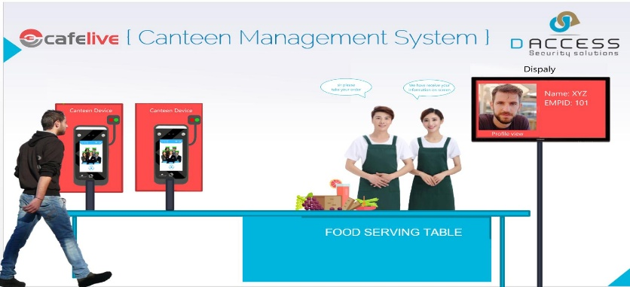

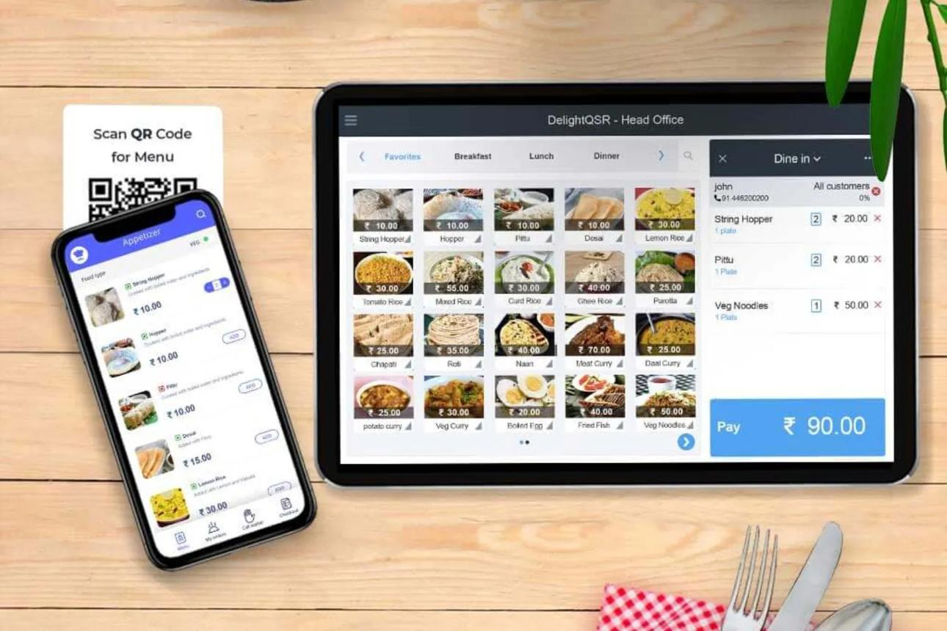

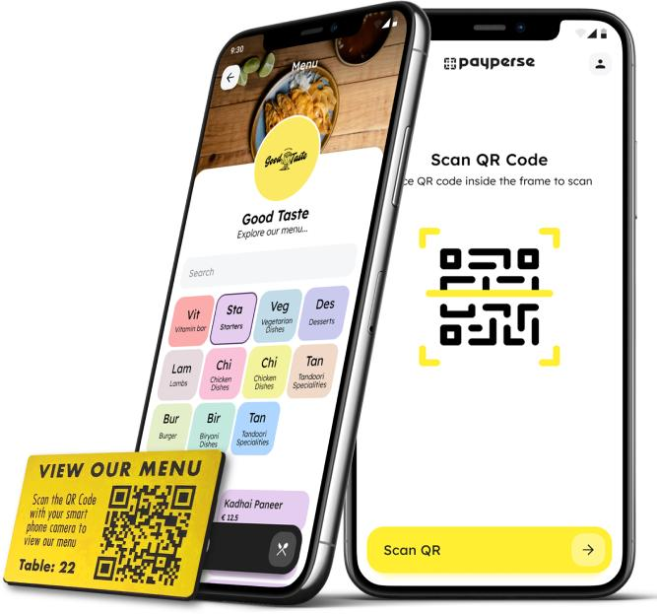
🔹 Introduction
A Smart Canteen Ordering System is an IoT-based solution that automates food ordering in canteens using mobile apps, kiosks, or QR codes. It reduces waiting time, improves efficiency, and enhances user experience.

🔹 Description
The system connects users, kitchen staff, and payment systems through IoT devices and cloud platforms. Customers place orders digitally, which are sent directly to the kitchen. Notifications and real-time updates ensure smooth operation.

🎯 Project Objectives
- Reduce waiting time in queues
- Automate order placement and billing
- Improve accuracy of orders
- Enable real-time tracking of orders
- Optimize kitchen workflow

⚙️ Requirements
Hardware:
- Raspberry Pi / Arduino
- Display screens / kiosks
- RFID / QR code scanner
- Wi-Fi module
Software:
- Mobile/Web app
- Database (MySQL/Firebase)
- Cloud server
- Payment gateway integration

📚 Literature Survey
- IoT enables real-time communication between devices and users for automation.
- Smart systems in food services improve efficiency and reduce human intervention.
- Digital ordering systems are widely used in smart campuses and restaurants.

❗ Problem Formulation
Traditional canteen systems face:
- Long queues
- Manual errors in orders
- Time wastage
- Poor management of peak hours
👉 The proposed system solves these using automation and real-time data flow.

🔐 Security Measures
- User authentication (login/password)
- Secure payment gateways (encryption)
- Data encryption (SSL/TLS)
- Role-based access (admin/user)
- Protection against unauthorized access

📌 Applications
- College/hostel canteens
- Corporate cafeterias
- Restaurants and food courts
- Smart campuses

IoT Precision Agriculture
System Overview

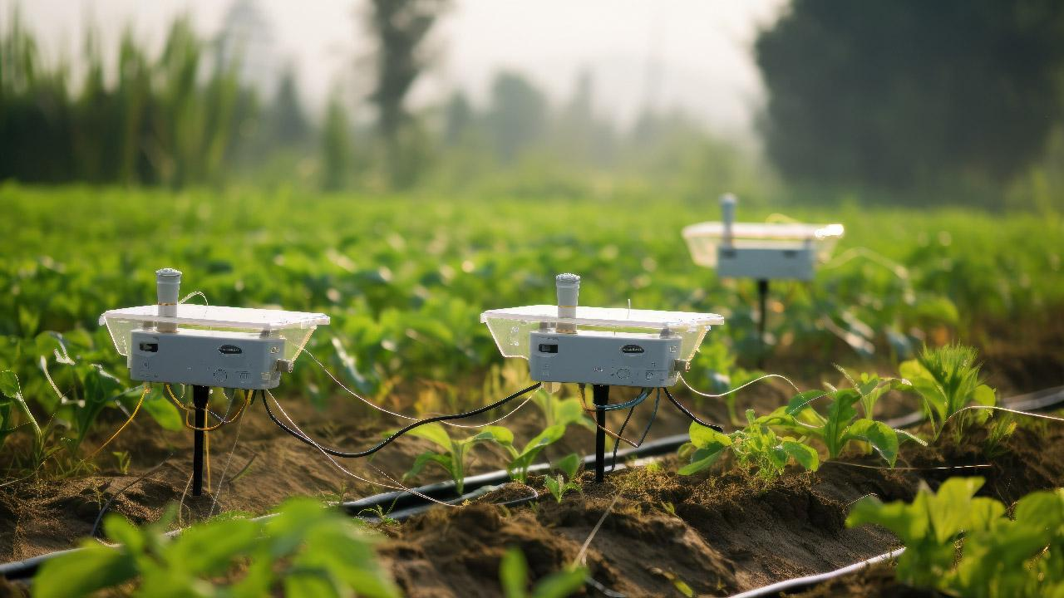
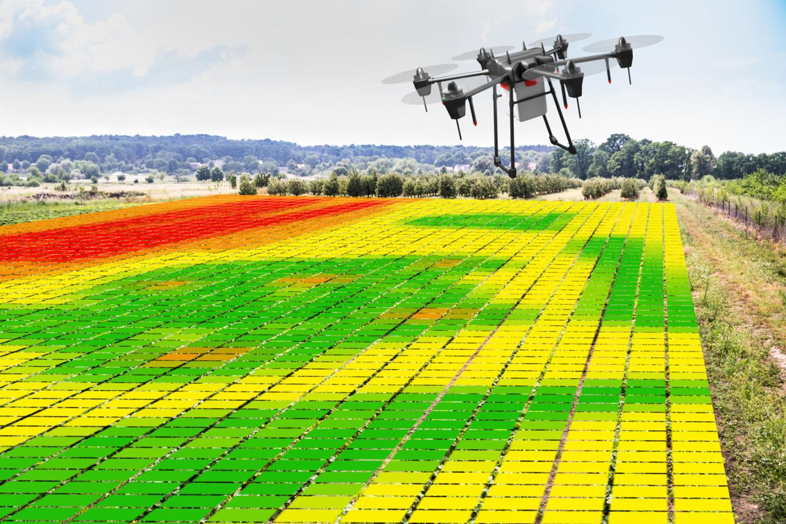
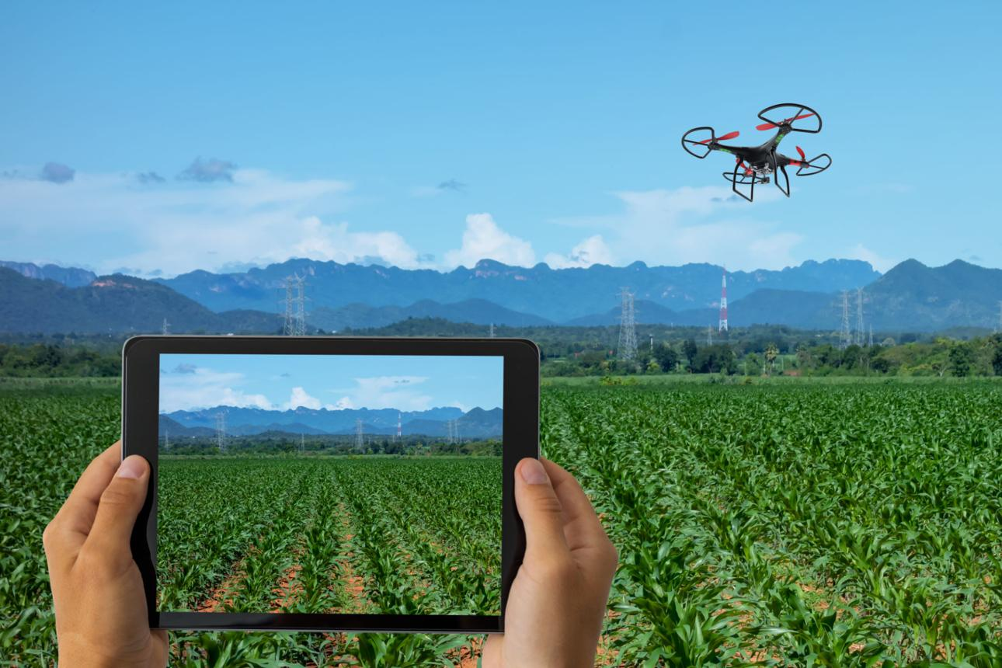

🔹 Introduction
IoT Precision Agriculture is a modern farming approach that uses sensors, IoT devices, and data analytics to improve crop yield, efficiency, and sustainability.

🔹 Description
Sensors collect data such as:
- Soil moisture
- Temperature
- Humidity
- Crop health
This data is analyzed and used to automate irrigation, fertilization, and monitoring systems.
👉 IoT-based farming helps in data-driven decision making and efficient resource use.

🎯 Project Objectives
- Increase crop yield and quality
- Optimize water and fertilizer usage
- Monitor crops in real-time
- Reduce human effort
- Enable smart decision-making

⚙️ Requirements
Hardware:
- Soil moisture sensor
- Temperature & humidity sensor (DHT11/DHT22)
- Arduino/Raspberry Pi
- Water pump (for irrigation)
- GPS/Drones (optional)
Software:
- IoT platform (ThingSpeak, Blynk)
- Cloud storage
- Data analytics tools
- Mobile/Web dashboard

📚 Literature Survey
- Precision agriculture uses ICT and IoT to improve yield and efficiency.
- Sensors collect real-time environmental data for better decision-making.
- IoT enables monitoring of soil, crops, and weather conditions continuously.

❗ Problem Formulation
Traditional farming problems:
- Excess water usage
- Low crop productivity
- Lack of real-time monitoring
- Manual decision-making
👉 IoT solves these through automation, monitoring, and predictive analytics.

🔐 Security Measures
- Secure IoT communication protocols (MQTT, HTTPS)
- Data encryption
- Device authentication
- Network security (firewalls)
- Protection against cyber threats in IoT systems

📌 Applications
- Smart irrigation systems
- Greenhouse monitoring
- Crop disease detection
- Weather monitoring
- Livestock tracking
- Precision fertilization

